**1/ BEHAVIOR TREE**

- Aims to develop a design from the functional requirements.

- Provides traceability between requirements and the design.

- Constructs a behavior tree for each requirement by:

+ Identifying components and states

+ Capturing behavior expressed

- Translate and integrate requirement:

+ Translate requirement: The first tasks are to identify the component (bold), identify the behaviors (underline) and identify indicators of the order (italics) in which behaviors take place.

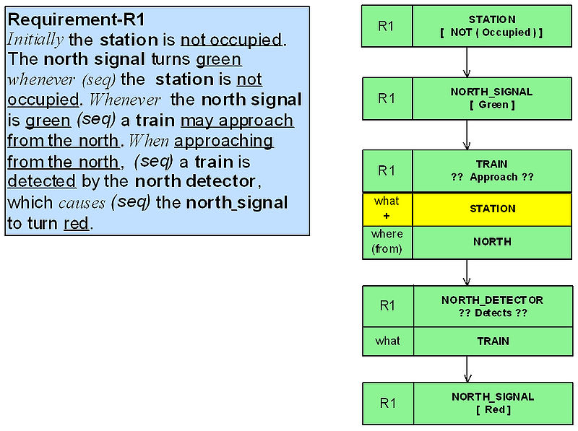

Example requirement translation

+ Integrate requirement: Once the set of requirements are formalized as individual requirement behavior trees, two joint properties of systems and requirements need to be exploited in order to proceed with composing the integrated behavior tree:

* In general, a fragment of behavior expressed by a requirement always has associated with it a precondition which needs to be satisfied before the behavior can take place (this precondition may or may not be expressed in the requirement).
* If the requirement is really part of the system then some other requirement in the set must establish the precondition.

*For requirements represented as behavior trees this amounts to finding where the root node of one tree occurs in some other behavior tree and integrating the two trees at that node.*

The example below illustrates requirements integration for two requirements, R1 and R3. In other words, it shows how these two requirements interact.

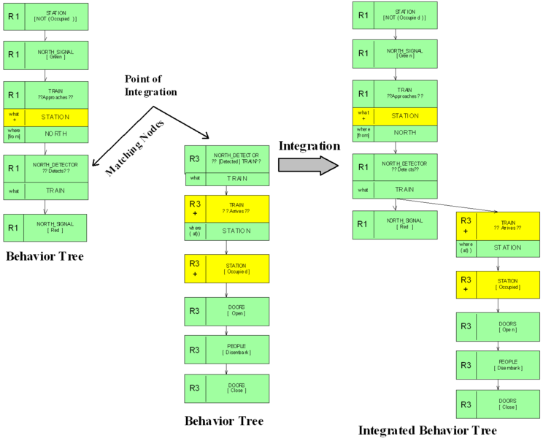

- Impact analysis using behavior tree:

* Where to make the change,
* How the change affects the architecture of the existing system,
* Which components of the system are affected by the change, and
* What behavioral changes will need to be made to the components (and their interfaces) that are affected by the change of requirements

**2/ DIAGRAM APPROACH**

- Uses standard diagrams to understand change impact

- There are 3 main types of diagrams:

+ Structural Diagram

+ Behavior Diagram

+ Interaction Diagram

- Entire system is modeled using each diagram type.